**CP Lab Project Report**



**CSE102l Computer Programming Lab**

**Department of Computer System Engineering**

**University of Engineering and Technology Peshawar**

Submitted to: **Abdullah Hamid**

Submitted by Group:

* **Muhammad Saad** 21PWCSE1997
* **Mujeeb-Ur-Rehamn** 21PWCSE2021
* **Muhammad Hashir Sajjad** 21PWCSE2087

**DCSE, Batch 23 , Section “B”**

**Project Title**

**Department Live Time Table**

**Description:**

This project was made to know which classes in the department are empty and which are not. Sometime if we have to take an arranged class and want to know which class is empty, we have to check time table of every semester or go to every class to see if it is empty or not. This code is just an easier way to do that.

**Topic used in this project:**

* Data structures
* Class
* Constructor
* Loops
* Condition statements

**Application of the project:**

This code will take present time as an input and then time will keep on going like a stop watch with the help of loops. There is an object array called “data”, the code will check if the times in the array matches, output will show which subject is being taught to which semester in which and by which teacher. It will also check classes of the next hour and show them on screen if there is any.

**Code**

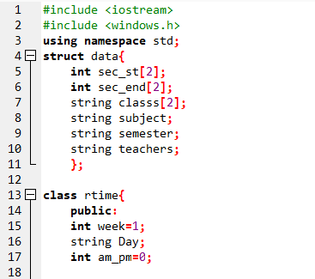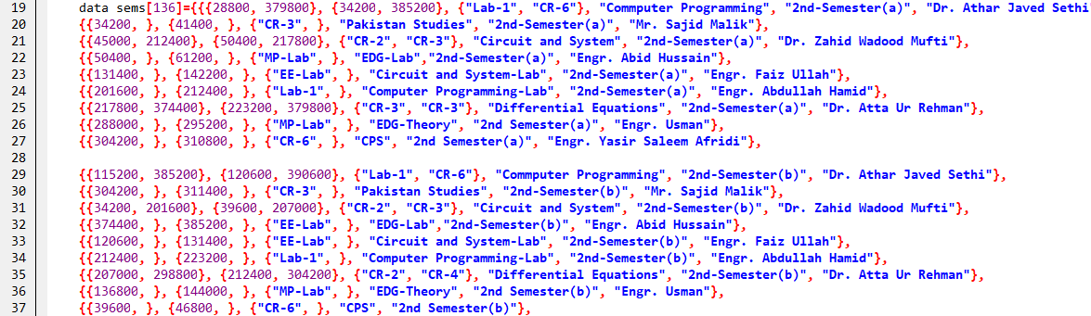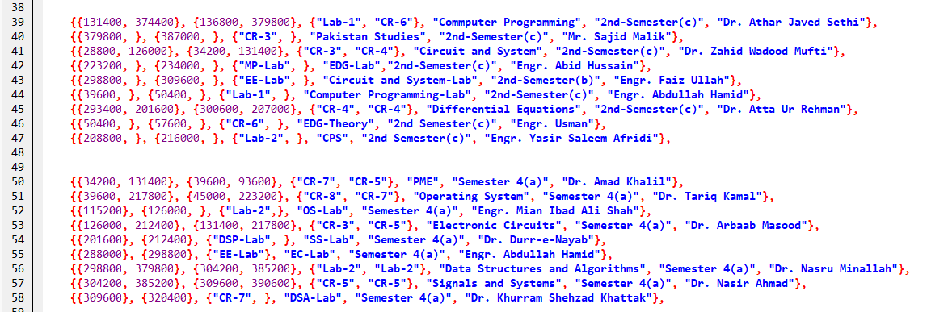

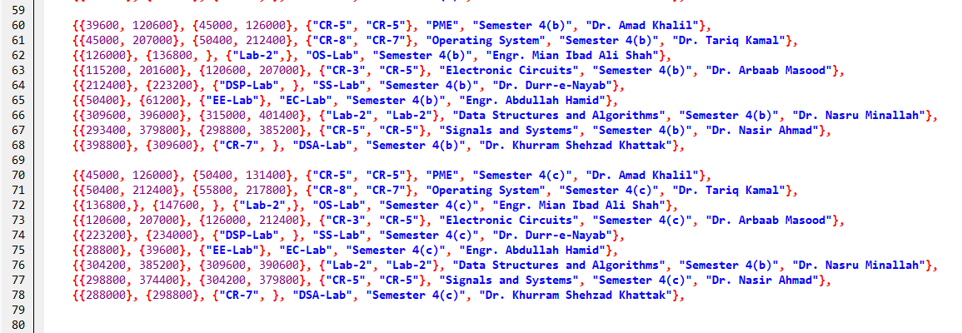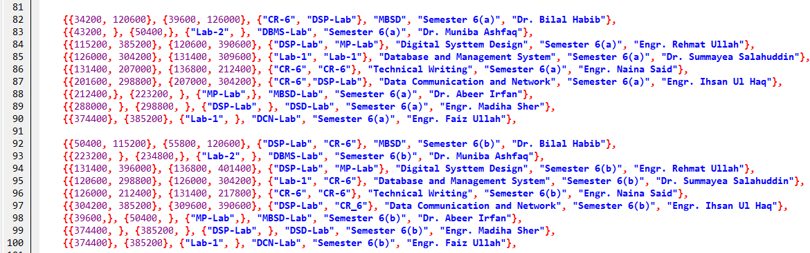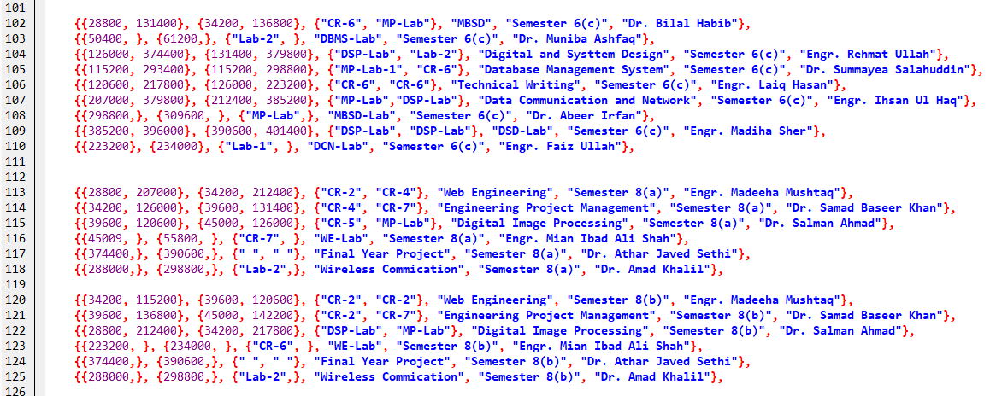

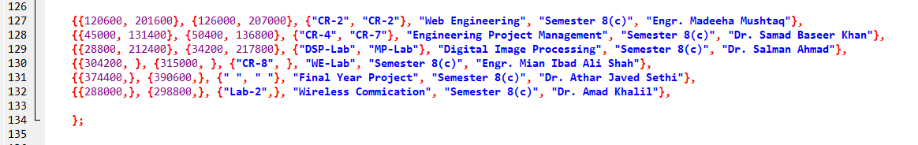

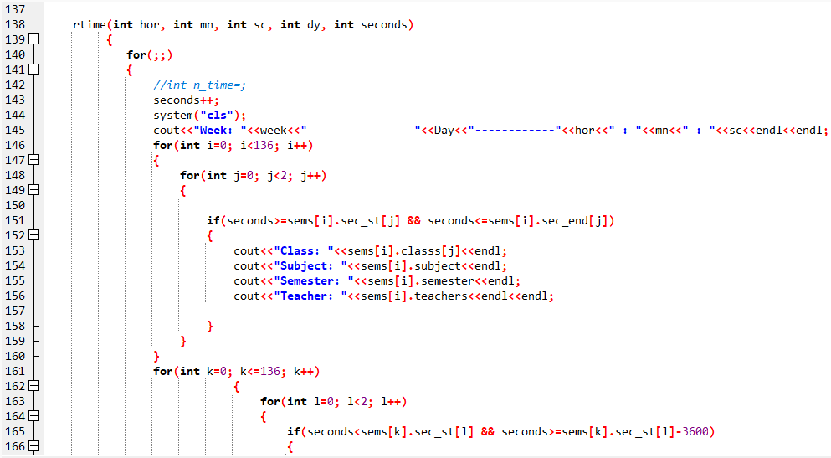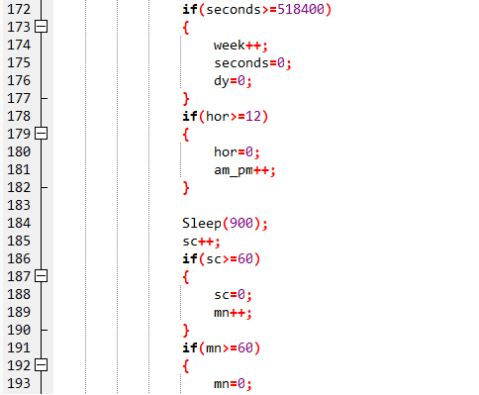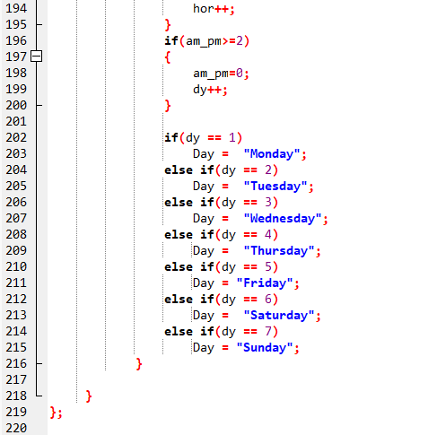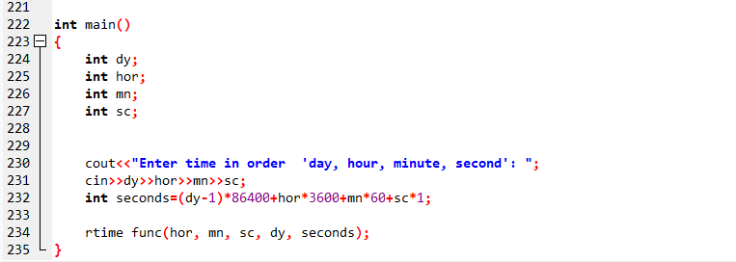

**Inputting Data**

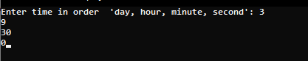

**Output**

